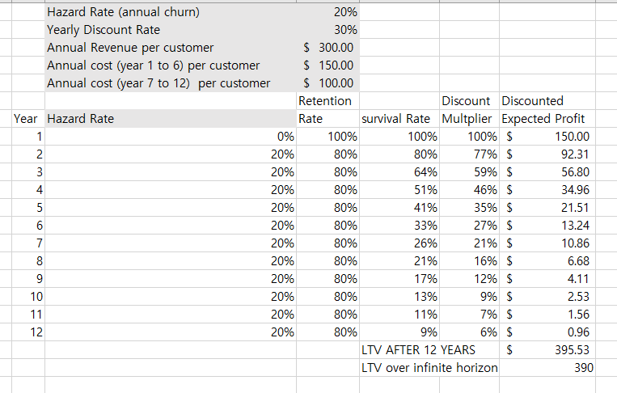

**Question a) At which YEAR in the customer lifecycle, the survival rate is around 50%? e.g., after 6th year, the survival probability of the customer (prob. of staying with the business) is around 50%.**

When it is year of 4 was around 50% of survival rate.

After 4th years, the survival probability of the customer is around 50%

**Question b) Calculate the LTV (CLV) after 12 Years of activity for a customer?**

The calculation of the LTV after 12 years of activity is $395.53.